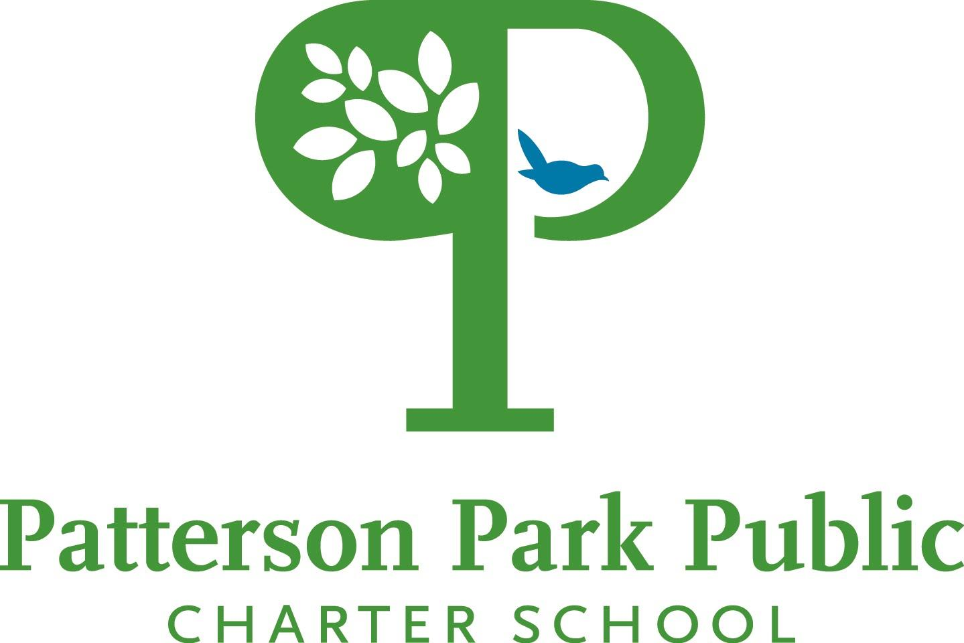

Prospective Board Member Application Form

2022-2023

We make every effort to have the composition of our board reflect the diversity of our community. Toward that end, we are asking for a variety of information. Please feel free to leave blank anything you do not wish to answer. Decisions will not be based on any single variable.

Date:

Name:
􀀀 Mr. 􀀀 Mrs. 􀀀 Ms. 􀀀 Dr. 􀀀 Honorable 􀀀Other ________________

Demographic Information

Gender: 􀀀 Male 􀀀 Female Age: 􀀀 21‐ 30 􀀀 31‐45 􀀀 46‐60 􀀀 61‐72 􀀀 over 72

Race/Ethnicity:

Contact Information:
Please place an X in the boxes beside the contacts you would like us to use.
􀀀 Home address:
􀀀 Phone:
􀀀 E‐mail:
􀀀 fax:
􀀀 Work address:
􀀀 Work phone:
􀀀 Work E‐mail:

Current Job title or description:

Spouse/Significant Other:

Children/Age:
Is your child a current PPPCS or CHPCS student or do you plan to enroll your child in the PPPCS or CHPCS lottery for enrollment?

Education
Graduate: Class of:
Undergraduate: Class of:
High School: Class of:

Interest/Connections
What is it about our vision and mission that interests you?

Which of our programmatic approaches, services or philosophy do you feel a particular affinity or connection to and why?

What is your understanding of how Charter Schools in Baltimore City function?

How did you hear about us?

Do you know anyone who is a board member, staff, parent, or organizational affiliate of PPPCS?

Networks:
Please briefly describe any professional and/or volunteer networks to which you have connection.

Board Memberships (Current and Past. Please list years of involvement)

Professional Expertise and Interests:
Place an X under “Expertise” for all areas you have experience that you would describe as expertise. Place an X under “Interest” for all the areas in which you have an interest in working as a board member, regardless of expertise (e.g., you may be a CPA but not have an interest in working on organizational finance).

 | Expertise | Interest
Financial
Marketing
Management
Public Relations
Legal
Public Speaking
Fundraising
Community Relations
Human Resources
Public Policy
Advocacy
Early Childhood Development
K-12 Education
Charter Schools
Academia/Higher Ed
Other: _______________________________

Board Committees
Our Board members each serve on one committee. Which committee(s)/projects would you be interested in?

􀀀 Finance Committee
􀀀 Development (fundraising) Committee
􀀀 Academic Excellence Committee
􀀀 Governance Committee
􀀀 Facilities Committee

Time: Our board meets 7:00 pm ‐ 9:00pm on the third Wednesday of the month except August. The annual board retreat is typically the second half of January. Our board committees also meet, on average, once a month for approximately 2 hours. Do you anticipate any ongoing conflict for meeting attendance? 􀀀 No 􀀀 Yes

Conflict of Interest
All board members complete and sign a Conflict of Interest form. Do you anticipate having a conflict of interest that would prohibit you from serving on the board of directors?
􀀀 No 􀀀 Yes

Background Check
All board members must complete a background check. The school will assist you with this process. Are you willing to complete a background check? 􀀀 No 􀀀 Yes

Thank You. Please email your completed application along with a resume or bio to:
Jane Lindenfelser, Executive Director at JLindenfelser@pppcs.org

